Falling Housing Prices and Underwater Mortgages - Full Answer
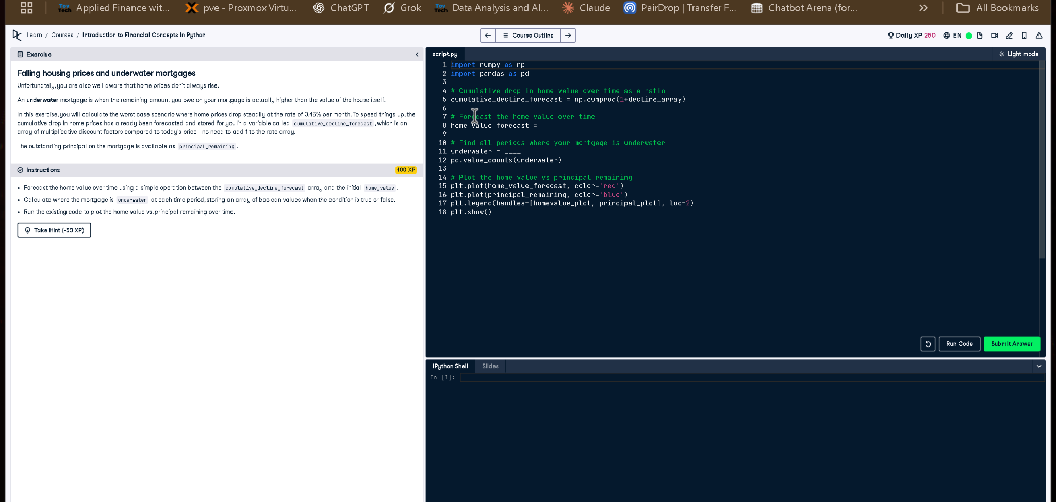

Full Code Answer:
import numpy as np
import pandas as pd
# Cumulative drop in home value over time as a ratio
cumulative_decline_forecast = np.cumprod(1 + decline_array)
# Forecast the home value over time
home_value_forecast = home_value * cumulative_decline_forecast
# Find all periods where your mortgage is underwater
underwater = principal_remaining > home_value_forecast
pd.value_counts(underwater)
# Plot the home value vs principal remaining
plt.plot(home_value_forecast, color='red')
plt.plot(principal_remaining, color='blue')
plt.legend(handles=[homevalue_plot, principal_plot], loc=2)
plt.show()

Question:
How do we calculate home value decline over time and determine when a mortgage becomes underwater?

20-word Explanation (Question):
An underwater mortgage occurs when the remaining principal surpasses current home value due to declining property market trends.

Answer:
We use np.cumprod() to calculate declining home values, then check if principal_remaining exceeds home_value_forecast for underwater status.

20-word Explanation (Answer):
By multiplying home value with cumulative decline factors, we compare it with principal_remaining to find underwater mortgage periods.

